START G:\ISA\fangx\ISA245\DataFile\ch3Clearwater.sql;
START G:\ISA\fangx\ISA245\DataFile\ch3Northwoods.sql;

--1
SELECT * FROM inventory
WHERE INV_QOH >0
AND (inv_size= 'M' OR inv_size= 'L')
AND (color IN ('Royal', 'Bright Pink', 'Sky Blue'));

INV_ID | ITEM_ID | COLOR | INV_SIZE | INV_PRICE | INV_QOH
13 | 4 | Royal | M | 59.95 | 124
14 | 4 | Royal | L | 59.95 | 112

--2
SELECT inventory.item_id , inventory.inv_size, inventory.color,inv_QOH*inv_price AS Value
FROM item
JOIN inventory ON item.item_id = inventory.item_id
WHERE item_desc = 'Boy''s Surf Shorts';

ITEM_ID | INV_SIZE | COLOR | VALUE
6 | S | Blue | 797.5
6 | M | Blue | 1595
6 | L | Blue | 1595

--3
SELECT COUNT ( * )
FROM orders
JOIN order_source ON orders.os_id = order_source.os_id
WHERE order_source.os_desc = 'Web Site';

--4
SELECT o_id, SUM(ol_quantity)
FROM order_line
GROUP BY o_id;
-- need to group by since you have the SUM function
O_ID | SUM(OL_QUANTITY)
1 | 3
6 | 4
2 | 1
4 | 2
5 | 2
3 | 2

--5
GRANT update, select ON orders TO fangx;
GRANT update, delete ON order_source TO fangx, igeljj;

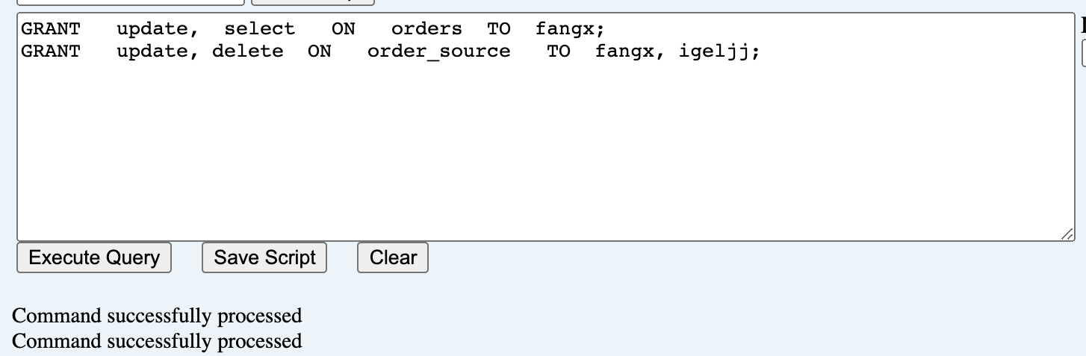

--6
UPDATE order_source
SET os_desc='WEB SITE'
WHERE os_id= '6';
--ROLLBACK;
-- Rollback is here so we can do undo this previous statement if needed
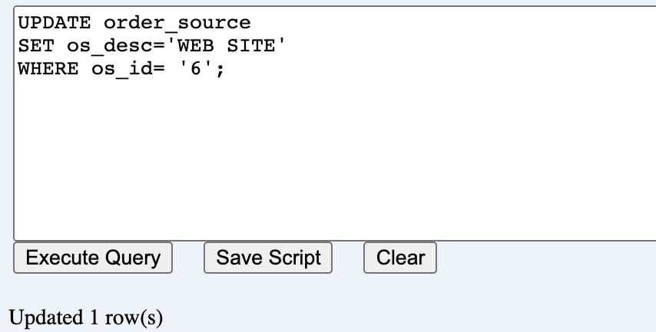

--7
ALTER TABLE inventory
DISABLE CONSTRAINT inventory_color_fk ;
DELETE FROM color
WHERE color='Sky Blue';
--ROLLBACK;
-- Rollback is here so we can do undo this previous statement if needed
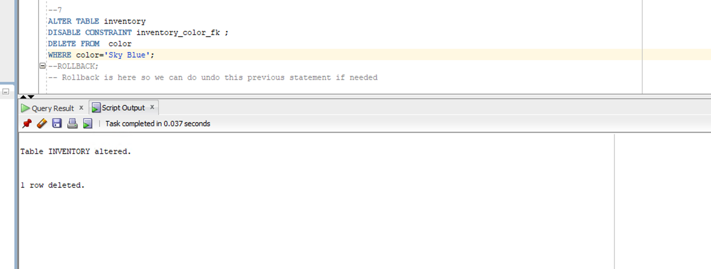

--8
SELECT DISTINCT course.course_no, grade
FROM course
JOIN course_section ON course.course_no = course_section.course_no
JOIN enrollment ON course_section.c_sec_id = enrollment.c_sec_id
JOIN student ON enrollment.s_id = student.s_id
WHERE s_first='Tammy'
AND s_last='Jones'
AND grade IS NOT NULL;
COURSE_NO | GRADE
MIS 441 | B
MIS 101 | A
MIS 451 | B
MIS 301 | A

--9
Select DISTINCT s_last, s_first
FROM student
JOIN enrollment ON student.s_id = enrollment.s_id
WHERE c_sec_id IN
-- use a query inside a query to get the info for Tammy
(SELECT c_sec_id
FROM student
JOIN enrollment ON student.s_id = enrollment.s_id
WHERE s_last='Jones'
AND s_first='Tammy');

S_LAST | S_FIRST
Johnson | Lisa
Jones | Tammy
Perez | Jorge
Marsh | John

--10.
SELECT *
FROM enrollment
WHERE grade NOT LIKE 'B' AND grade NOT LIKE 'C';

S_ID | C_SEC_ID | GRADE
JO100 | 1 | A
JO100 | 4 | A
PE100 | 6 | A

